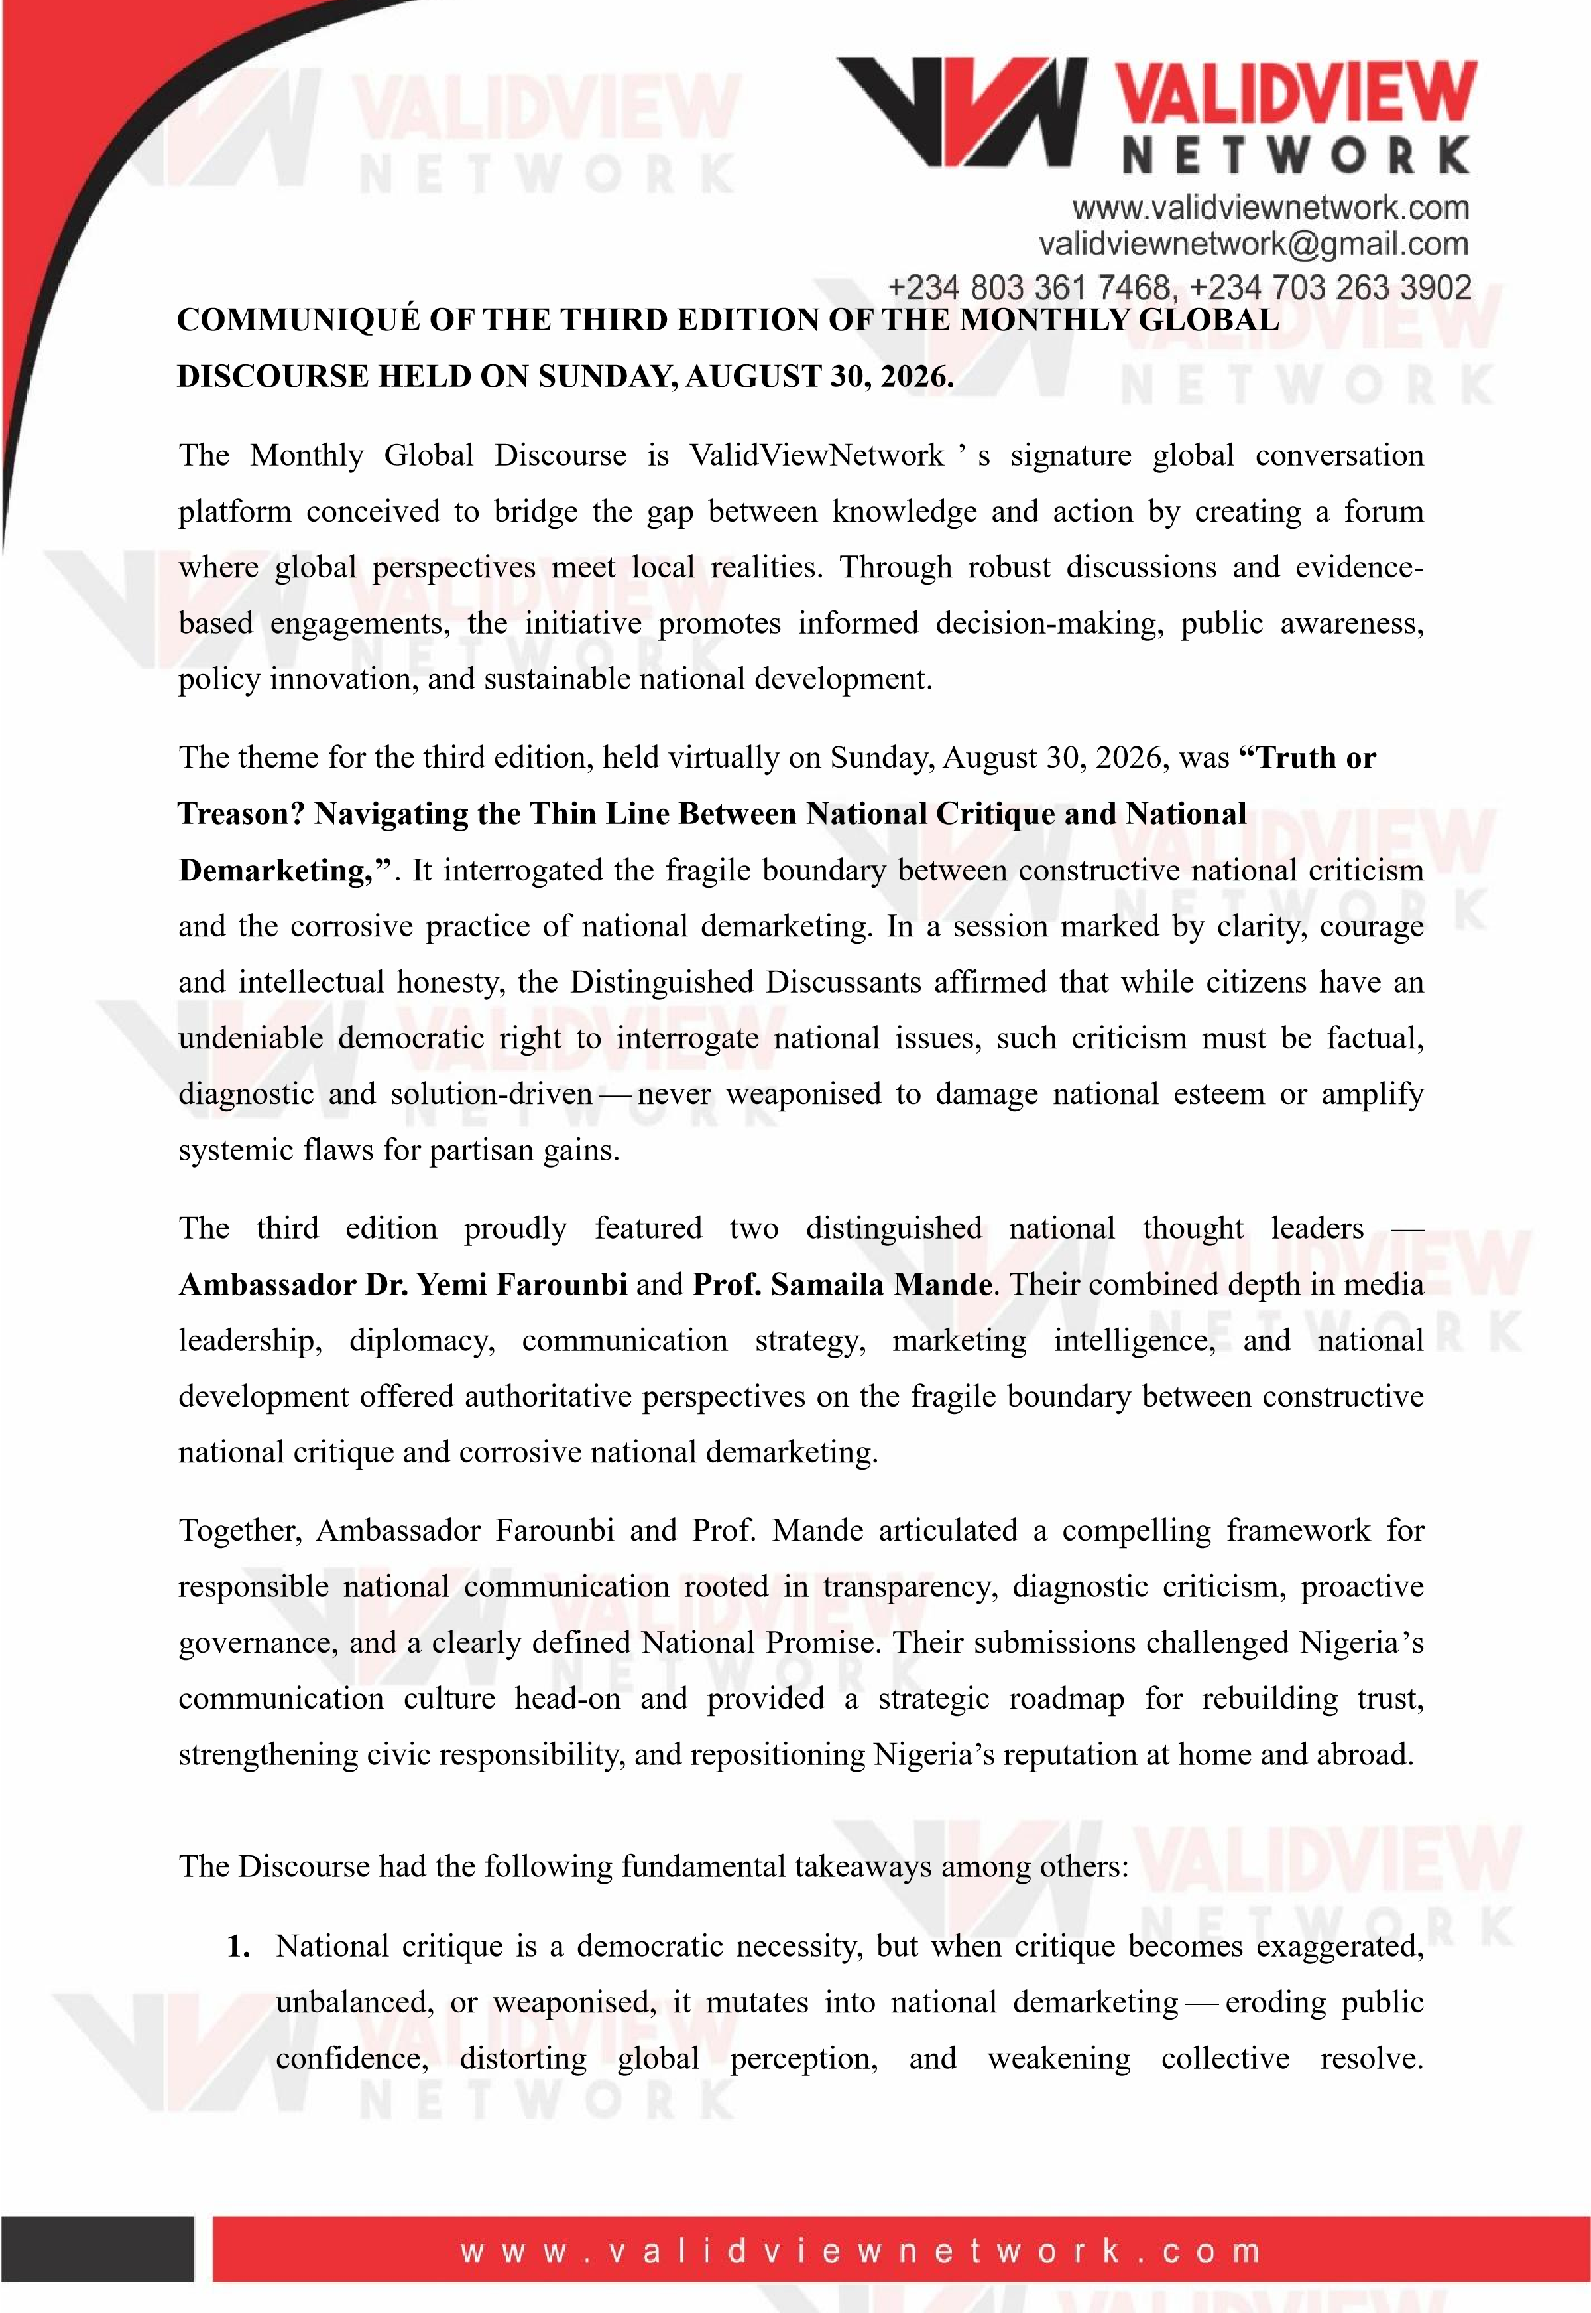
Distinguished Discussants affirmed that citizens could criticise effectively without demarketing when criticism is based on facts, values, diagnostic analysis, and solution-driven alternatives. Criticising without offering alternatives is tantamount to demarketing.
- Patriotism does not demand silence, but it demands responsibility. Citizens must learn to differentiate between constructive criticism that strengthens the nation and destructive narratives that sabotage it.
- Politicians must tell the electorate the whole truth rather than playing to the gallery. Political theatrics, half-truths, and sensational statements—whether made in major cities or remote corners — travel faster than imagination and damage national credibility.
- A demarketer knows exactly what he is doing and deliberately works on the psyche of the people. Demarketing amplifies systemic flaws without offering remedies and damages the self-esteem of citizens.
- It is erroneous to tag corruption or fraudulence as “Nigerian language.” These vices are not cultural identities of Nigeria otherwise they would not have been in the dictionary. Nigeria must reject such damaging labels.
- Nigeria must advance openness and transparency to endear citizens globally. The rights of citizens to interrogate issues in a democracy cannot be overemphasised. The Trust Gap between government and the governed is widening at an alarming rate, driven by opacity, inconsistent communication, and dismissive attitudes toward opposing views.
- Statements such as “Nigeria has happened to me” arise from broken Service Level Agreements. Disagreement in service delivery fuels frustration and demarketing. Agencies of government must be proactive, eliminate middlemen and tout-driven processes, and strive to meet the yearnings of the people.
- The Minister of Interior, Dr. Olubunmi Tunji-Ojo, was commended for transformative initiatives and giant strides in immigration reforms, demonstrating how effective leadership can reshape national perception.
- Nigeria’ s reactionary posture in crisis situations was identified as a recurring weakness. Response to crisis must be immediate, transparent, and functional. Government must develop institutional response mechanisms that anticipate issues, manage risks, and provide structured, proactive communication.
- Government must establish well-documented and widely circulated crisis communication protocols. Standard Operating Procedures (SOPs) were strongly advocated as essential tools for consistency, accountability, and clarity in public service delivery.
- Data and information should be readily available to promote openness. NELFUND must be transparent, with accessible data to eliminate doubt, suspicion, and criticism.
Open data systems strengthen trust and evidence-based national discourse.
- Government’s tendency to dismiss opposing views as politically sponsored was criticised. Many dissenting opinions reflect genuine national realities and should inform policy improvement. Government must not distort facts and must remain humble enough to make corrections where necessary.
- Inconsistencies in government communication such as claiming power generation is increasing while citizens experience daily collapse widen the trust gap. Differing statements especially on sensitive issues like fuel subsidy removal, create confusion among the citizens and erode confidence. Unified messaging frameworks were recommended.
- Spokespersons must stop manipulating citizens and instead market the visions, policies, and achievements of government. For a journalist to succeed as a spokesperson, they must shed the adversarial persona of newsroom reporting and retrain in strategic PR, narrative management, communication art and stakeholder engagement.
- Government has the right to intervene when there is outright demarketing, but such intervention must remain within the confines of the law and must not trample on citizens’ rights. Government must not turn itself into a terrorist.
- Nigeria must be strategically packaged and branded. The nation must clearly articulate its National Promise — a unifying declaration of national values, aspirations, and commitments that guide governance and citizen engagement.
- Influencers have a major role in redirecting the thought-process of the people. Sensationalism, unverified claims, and emotionally charged reporting contribute to national demarketing and deepen public distrust. They must fact-check information and resist the lure of clicks or pecuniary benefits. Ethical influence is essential for national stability.
- All eyes must be on systemic solutions rather than amplifying challenges. Leaders and citizens must avoid sweeping generalisations that portray Nigeria as irredeemably flawed.
- Diasporans contribute immensely to the economy and must see openness, transparency, and appropriate institutional frameworks that encourage them to invest and do business.
- In many cases, leaders create problems that drift followers into demarketing and speculation. Followers must hold leaders accountable for moral, social, and political decadence. Nigerians must begin to ask questions from their representatives and call them to action. It is a shame for non-performing legislators to return to power year after year.
- Nigerians are wonderful and resourceful people; what is needed is to catalyse their resourcefulness through good governance, value reorientation, and institutional support. When properly catalysed, Nigerian ingenuity can drive national transformation and global competitiveness.
- The mindset of an average Nigerian politician—to amass wealth—must change for Nigeria to move forward and for the wave of demarketing to cease. Leadership must be redefined as service, not accumulation.
- The importance of platforms like the ValidViewNetwork Monthly Global Discourse in fostering evidence-based dialogue and shaping the thought pattern of Nigerians was commended. The platform was encouraged to continue to expand its reach and deepen its engagement with diverse national stakeholders.
The third edition of the monthly discourse affirmed that Nigeria requires a deliberate, nationwide mindset reset that promotes civic responsibility, national pride, and informed engagement without suppressing legitimate dissent.
It resolved that National critique remains a democratic necessity and that when criticism is exaggerated, unbalanced, or weaponised, it mutates into national demarketing eroding public confidence, distorting global perception, and weakening collective resolve. The Distinguished Discussants frontally kicked against weaponising national weaknesses for partisan advantage.
ValidViewNetwork expresses sincere appreciation to our Distinguished Discussants and participants for their invaluable insights and meaningful contributions to the discourse.
The fourth edition of the Monthly Global Discourse, scheduled for Sunday, September 27, 2026, will place another important topical issue on the front burner as ValidViewNetwork continues its commitment to evidence-based civic engagement and mindset renewal.
ValidViewNetwork Limited founded by Dr Kayode Ogunjobi FHEA, FFAN, stands firmly on three strategic pillars—Media, Consultancy, and Advocacy, all working together to deliver credible news reporting, expert environmental and academic advisory services, and impactful public-interest advocacy. Through this integrated structure, it advances evidence-based communication, sustainable development solutions, institutional strengthening, and community-focused interventions that promote environmental protection, academic excellence, and societal well-being.

E- Signed
Dr Kayode Ogunjobi FHEA, FFAN
Founder & CEO

